Work log

Assignment 3 – COMP612

Duc Nguyen

Student ID: 17974984

Table of Contents

18/6/2020 3

4:30pm 3

7:30pm 3

# 18/6/2020

## 4:30pm

Created a new project for Assignment 3, used files from Assignment 2 as a base.

Because my assignment 2 failed to use hierarchical model, I read through the example code and make changes to my current helicopter model.

I created TreeNode.java with functions similar to the one on blackboard. My current classes for helicopter parts extends this TreeNode class and I have implemented the abtract methods in these helicopter parts classes. In the future, I will create a HeliPart class so I can narrow down the number of duplicated functions, but now for testing purpose, I will keep the structure as it is.

In Helicopter.class, because I only draw body because I have linked it to other parts.

## 7:30pm

I am now struggling with translate other parts based on body position. Yes, I should have implemented Tree model earlier.

I have to calculate positions again.

## 8:31pm

Finished converting to tree model.

For HeliBody, I have used variable instead of fixed number to match all components

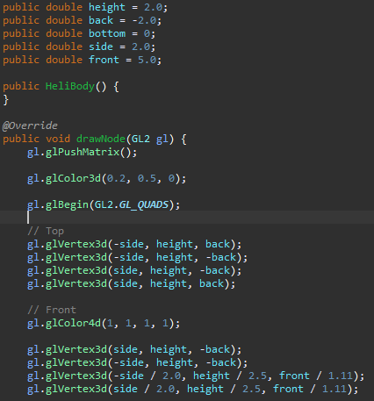

This is also used for transformation of other helicopter’s parts.

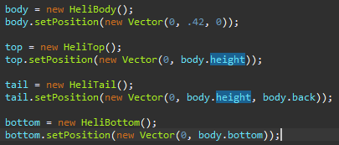

I will start writing HeliPart.java to reduce the number of duplicate functions now. I will also create a Motor class for the blades on top and also on tail.

## 10:46pm

Finished HeliPart class and Motor class. Motor class was pretty easy as I only have to copy the code over and update their position to comply with HeliPart